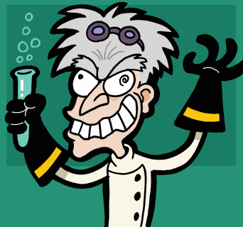
"They laughed at my theories at the Institute!
Fools! I'll destroy them all!"

-- Caucasian, male, aging, crooked teeth, messy hair, spectacles/goggles, dramatic posing — A very stereotypical mad scientist.

A mad scientist is a stock character* of popular fiction, either villanous, or benignly unconscious and scatter-brained. Whether insane, eccentric, or simply bumbling, the mad scientist is usually working with some utterly fictional technology in order to forward his evil schemes. Alternatively, he (female mad scientists are very rare) doesn't see the evil that will ensue from his hubris in "playing God".

Defining characteristics
Mad scientists are typically characterized by obsessive behaviour and the employment of extremely dangerous or unorthodox methods. They often are motivated by revenge, seeking to settle real or imagined slights, typically related to their unorthodox studies.
Their laboratories often hum with Tesla coils, Van de Graaff generators, Jacob’s ladders, perpetual motion machines, and other visually impressive electrical oddments, or are decorated with test tubes and complicated distillation apparatus containing strangely-colored liquids with no obvious purpose.
Other traits include:
- Pursuit of science without regard to its ethical implications (such as violating the Nuremberg Code)
- Self-experimentation
- Playing God, tinkering with Nature, often with analogies to young boys
- Lack of normal relationships
- Perpetually unkempt appearance or physical deformity
- In English-language works: Speaking with a German or Eastern European accent. (This was in large part the result of many scientists from Germany and Eastern Europe emigrating to the United States in two waves: one before World War II comprised of refugees from Nazism, and one after the war comprised of refugees from the Soviet Union and, in some cases, former Nazi employees.
- In villains, maniacal laughter, especially pronounced when their experiments reach their climax.
- They have some academic degree, usually Dr. or Professor .

It is notable that most of these traits are little more than exaggerations of typical stereotypes of normal scientist behavior: Scientists are often obsessive about their work, take a dim view of societal considerations that interfere with it, are perpetually adopting a "disinterested" worldview for the purposes of objectivity, etc. There is no firm dividing line between sane scientists and mad scientists, and the ones mentioned in the rest of this article cover the entire spectrum.

Source: Answers.com

* A stock character is a fictional character that relies heavily on cultural types or stereotypes for its personality, manner of speech, and other characteristics. Stock characters are instantly recognizable to members of a given culture. Because of this, a frequent device of both comedy and parody is to wildly exaggerate the expected mannerisms of stock characters.

